Joostenberg Estate, die agteros chenin blanc 2025
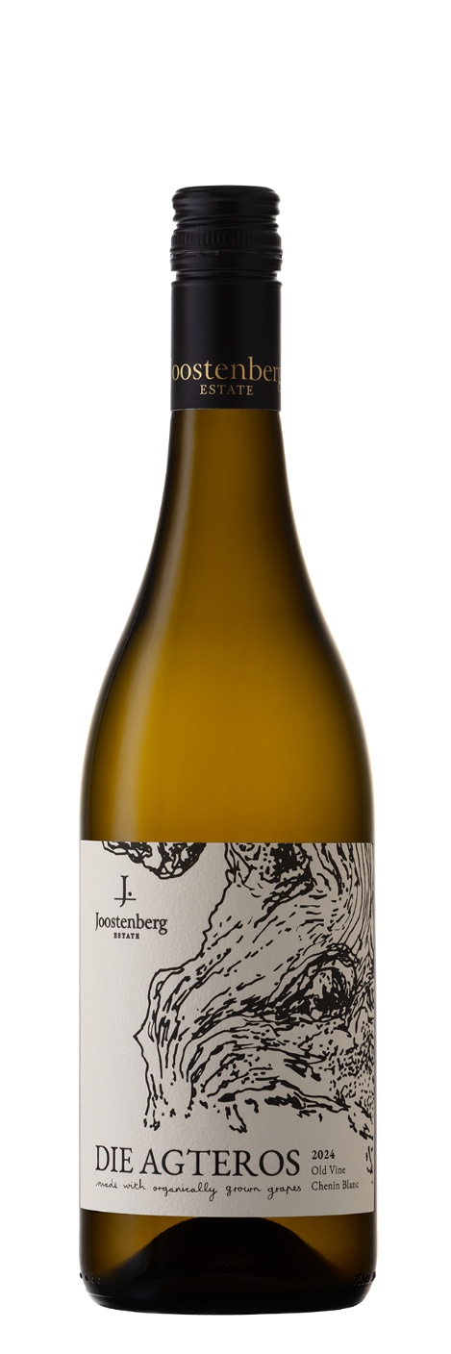
When oxen were used as draft animals the youngest, least experienced ox was positioned at the rear of the team. As he got stronger and more skilled he worked his way to the front, hence the Afrikaans saying "agteros kom ook in die kraal", meaning "the hind ox gets there eventually”. These grapes come from the oldest vineyard on the farm, planted in 1989. This lovingly tended vineyard was under-valued for many years before its real potential was noticed.

TASTING NOTES
Medium-bodied and dry. Apple pie, honey-comb and a touch of flint on the nose. Good balance between freshness and richness on the palate with a long finish.

Vineyard
A new vineyard was used in 2024 as the vineyard used in previous vintages (2014-2023) was uprooted. Although a little concerned about the impact of the change, the quality of the grapes from this vineyard were exceptional and the resultant wine more than matches that made in previous vintages from the former vineyard.
- Dry-farmed vineyard planted in 1989.
- East facing at 180m altitude and 27km from the coast.
- Soil is a combination of granite and clay shale.
- In order to optimize the influence of terroir the vineyards are managed according to organic and regenerative principles.

Vinification
Hand-picked and whole-bunch pressed. Spontaneous fermentation and then maturation in seasoned barrels (43%), concrete "eggs" (47%) and ceramic amphorae (10%). 100% Malolactic fermentation and 8 months maturation on the lees.
The wine was subjected to minimal stabilization and filtration.

ANALYSIS
Alc: 12.7%, RS: 2.3 g/l, TA: 5.7 g/l, pH: 3.26

